***Dt : 2/9/2022***

***\*imp***

***Loading data to Objects:***

***=>we use the following ways to load the data to Objects:***

***Process-1 : Using Constructor***

***=>we use Constructor to load the data to object while Object***

***creation process and which saves the execution time and generate***

***HighPerformance of an application.***

***Ex:***

***DemoCon3.java***

***Process-2 : Using 'Object reference Variable'***

***=>we can use 'Object reference Variable' or 'Object name' to load***

***the data onto Object.***

***Ex:***

***DemoMethods6.java***

***Process-3 : Using 'Setter methods'***

***=>We can also use 'Setter methods' to load the data to the Object.***

***Ex-Program:***

***wap to read and display Employee details,using 'Setter method'***

***and 'Getter method'?***

***DemoCon4.java***

***import java.util.Scanner;***

***class Employee //SubClass***

***{***

***String id,name,desg;***

***int bSal;***

***float totSal;***

***void setEmployee(String id,String name,String desg,int bSal,***

***float totSal)***

***{***

***this.id = id;***

***this.name = name;***

***this.desg = desg;***

***this.bSal = bSal;***

***this.totSal = totSal;***

***}***

***void getEmployee()***

***{***

***System.out.println("====Display Employee====");***

***System.out.println("EmpId:"+id);***

***System.out.println("EmpName:"+name);***

***System.out.println("EmpDesg:"+desg);***

***System.out.println("EmpBSal:"+bSal);***

***System.out.println("EmpTotSal:"+totSal);***

***}***

***}***

***class DemoCon4 //MainClass***

***{***

***public static void main(String[] args)***

***{***

***Scanner s = new Scanner(System.in);***

***System.out.println("Enter the EmpId:");***

***String id = s.nextLine();***

***System.out.println("Enter the EmpName:");***

***String name = s.nextLine();***

***System.out.println("Enter the EmpDesg:");***

***String desg = s.nextLine();***

***System.out.println("Enter the EmpBSal:");***

***int bSal = s.nextInt();***

***float totSal = bSal+(0.93F*bSal)+(0.63F*bSal);***

***Employee e = new Employee();***

***e.setEmployee(id,name,desg,bSal,totSal);***

***e.getEmployee();***

***}***

***}***

***o/p:***

***Enter the EmpId:***

***A121***

***Enter the EmpName:***

***Raj***

***Enter the EmpDesg:***

***SE***

***Enter the EmpBSal:***

***15000***

***====Display Employee====***

***EmpId:A121***

***EmpName:Raj***

***EmpDesg:SE***

***EmpBSal:15000***

***EmpTotSal:38400.0***

***=====================================================***

***Summary:***

***(i)Using 'Contructor' we can load the data to object while object***

***creation process.***

***(ii)Using 'Object reference variable' and 'Setter method' we can***

***load the data to object after object creation process.***

***=========================================================***

***faq:***

***wt is the diff b/w***

***(i)Setter methods***

***(ii)Getter methods***

***(i)Setter methods:***

***=>Setter methods are used to set the data to the objects,which***

***means loading the data to the objects.***

***(ii)Getter methods:***

***=>The methods which are used to get the data from the objects***

***are known as Getter methods.***

***Coding Rule:***

***=>Every Variable in class will have its own Setter method and***

***Getter method.***

***==========================================================***

***faq:***

***wt is the diff b/w***

***(i)Instance block***

***(ii)Constructor***

***=>Both components are executed while object creation process,but***

***Instance block will have highest priority in execution than***

***Constructor.***

***faq:***

***wt is the diff b/w***

***(i)Static block***

***(ii)Constructor***

***(i)Static block:***

***=>Static block is executed only once when the class is used for***

***the first time.***

***(ii)Constructor:***

***=>Constructor is executed only once while object creation***

***process.***

***Ex-Program : DemoCon5.java***

***class CTest //SubClass***

***{***

***static***

***{***

***System.out.println("=====Static block====");***

***}***

***{***

***System.out.println("====Instance block===");***

***}***

***CTest()***

***{***

***System.out.println("====Constructor====");***

***}***

***}***

***class DemoCon5 //MainClass***

***{***

***public static void main(String[] args)***

***{***

***CTest ob = new CTest();***

***}***

***}***

***o/p:***

***=====Static block====***

***====Instance block===***

***====Constructor====***

***--------------------------------------------------------***

***faq:***

***define default constructor?***

***=>The Constructor without parameters which is added by the***

***compiler at compilation stage is known as default constructor.***

***faq:***

***In wt situation default constructor is added?***

***=>The compiler at compilation stage finds any Class without***

***Constructors will be added with default constructor.***

***-------------------------------------------------------***

***Note:***

***=>The class can be declared with any number of multiple constructors***

***without restriction,but only one constructor is executed based on***

***Con_Call available in Object creation syntax.***

***Ex:***

***DemoCon6.java***

***class CTest //SubClass***

***{***

***CTest()***

***{***

***System.out.println("===0-para====");***

***}***

***CTest(int x)***

***{***

***System.out.println("===Con with 1-para====");***

***System.out.println("The value x:"+x);***

***}***

***CTest(int y,int z)***

***{***

***System.out.println("===Con with 2-para===");***

***System.out.println("The value y:"+y);***

***System.out.println("The value z:"+z);***

***}***

***}***

***class DemoCon6 //MainClass***

***{***

***public static void main(String[] args)***

***{***

***System.out.println("****ob1*****");***

***CTest ob1 = new CTest();//Con_call_with_0_para***

***System.out.println("****ob2*****");***

***CTest ob2 = new CTest(12);//Con_call_with_1_para***

***System.out.println("****ob3*****");***

***CTest ob3 = new CTest(13,14);//Con_call_with_2_para***

***}***

***}***

***o/p:***

***\*\*\*\*ob1\*\*\*\*\****

***===0-para====***

***\*\*\*\*ob2\*\*\*\*\****

***===Con with 1-para====***

***The value x:12***

***\*\*\*\*ob3\*\*\*\*\****

***===Con with 2-para===***

***The value y:13***

***The value z:14***

***====================================================***

***Dt : 3/9/2022***

***faq:***

***wt is the behaviour of Constructor declared with return_type?***

***=>when the Constructor is declared with return_type,then it is***

***considered as normal method.***

***Ex : DemoCon7.java***

***class CTest //SubClass***

***{***

***CTest()***

***{***

***System.out.println("====CTest()====");***

***}***

***void CTest(int x)***

***{***

***System.out.println("====void CTest()====");***

***System.out.println("The value x:"+x);***

***}***

***}***

***class DemoCon7 //MainClass***

***{***

***public static void main(String[] args)***

***{***

***CTest ob = new CTest();//Con_call***

***ob.CTest(121);***

***}***

***}***

***o/p:***

***====CTest()====***

***====void CTest()====***

***The value x:121***

***=========================================================***

***faq:***

***define static Constructor?***

***=>There is no concept of static constructor in Java,because***

***Constructor means executed while object creation process and cannot***

***be at class_level.(Compilation Error)***

***===========================================================***

***faq:***

***wt is the diff b/w***

***(i)function***

***(ii)Member function***

***(iii)Method***

***(i)function:***

***=>The part of program which is executed outof main() program***

***in c-lang is known as function.***

***(ii)Member function:***

***=>The function which is declared as member of class in c++ lang***

***is known as Member function.***

***Note:***

***=>The member function can be declared inside the class and outside***

***the class.***

***(iii)Method:***

***=>The function which is declared only inside the class in Java***

***lang is known as Method.***

***===========================================================***

***\*imp***

***Packages in Java:***

***=>package is a collection of 'Classes and Interfaces'.***

***=>Packages in Java are categorized into two types:***

***1.Pre-defined packages***

***2.User defined packages***

***1.Pre-defined packages:***

***=>The packages which are already defined and available from***

***JavaLib are known as Pre-defined packages or Built-in packages.***

***=>The following are some important packages from JavaLib:***

***java.lang - Language package(default package)***

***java.util - Utility package***

***java.io - Input Output Stream package***

***java.net - Networking package.***

***\*imp***

***2.User defined packages:***

***=>The packages which are defined by the programmer are known as***

***User defined packages or Custom Packages.***

***=>we use 'package' keyword to define packages.***

***syntax:***

***package package_name;***

***===========================================================***

***Note:***

***=>Download and Install IDE Eclipse using the following link:***

***https://www.eclipse.org/downloads/***

***=>select : Eclipse IDE for Enterprise Java and Web***

***============================================================***

***\*imp***

***Creating Java Project using IDE Eclipse:***

***(IDE - Integrated Development Environment)***

***step-1 : Open IDE eclipse,while opening name the WorkSpace(folder)***

***and click 'Launch'***

***step-2 : Create Java Project***

***Click on File->new->Project->Java->select 'Java Project' and click***

***'next'->name the project and click 'finish'***

***step-3 : Create packages in 'src'***

***RightClick on 'src'->new->package,name the package and click 'finish'***

***step-4 : Create classes in packages***

***RightClick on package->new->Class,name the class and click 'finish'***

***Note:***

***=>To increase the font,click on Window->Preferences->General->***

***Appearance->Colors and fonts->Java->Java Editor Text font->...***

***CalculateSalary.java(SubClass)***

***package p1;***

***public class CalculateSalary {***

***public float calculate(int bSal)***

***{***

***return bSal+(0.93F*bSal)+(0.63F*bSal);***

***}***

***}***

***EmpMainClass.java(MainClass)***

***package p2;***

***import java.util.Scanner;***

***import p1.CalculateSalary;***

***public class EmpMainClass {***

***public static void main(String[] args) {***

***Scanner s = new Scanner(System.in);***

***System.out.println("Enter the bSal:");***

***int bSal = s.nextInt();***

***if(bSal>=12000)***

***{***

***CalculateSalary cs = new CalculateSalary();***

***float totSal = cs.calculate(bSal);***

***System.out.println("TotSal:"+totSal);***

***}***

***else***

***{***

***System.out.println("Invalid bSal...");***

***}***

***s.close();***

***}***

***}***

***step-5 : Execute the program***

***Open MainClass then Click Run->Run***

***===========================================================***

***Diagram:***

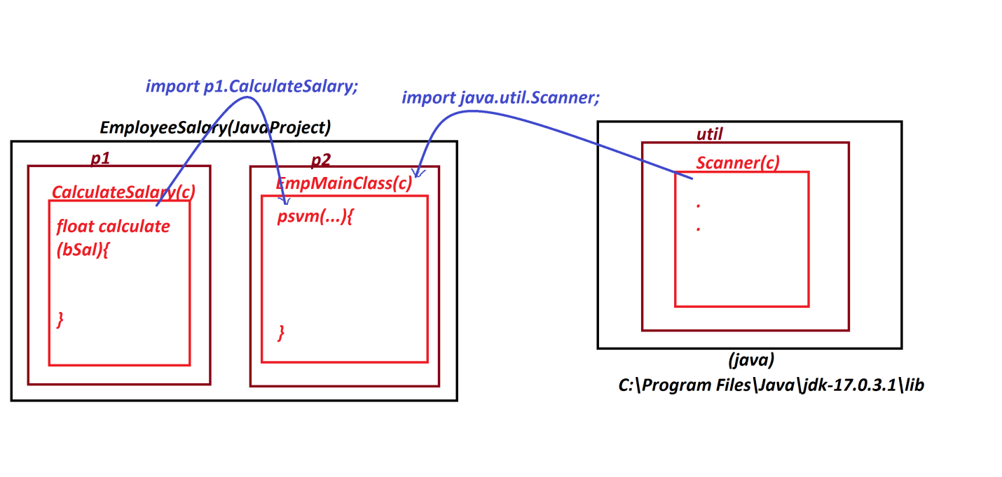

***===========================================================***

***Assignment-1:***

***JavaProject : StudentResult_App***

***packages,***

***p1 : CheckBranch,TotalMarks,Percentage***

***p2 : StudentMainClass***

***Assignment-2:***

***JavaProject : ArithmeticOperations_App***

***packages,***

***p1 : Addition,Subtraction,Multiplication,Division,***

***ModDivision***

***p2 : ArithmeticMainClass***

***================================================================***